

**NMAM INSTITUTE OF TECHNOLOGY**

(A unit of Nitte Education Trust)

Nitte - 574 110, Karkala taluk, Udupi Dist., Karnataka

**Department of Computer Science and Engineering.**

**RDBMS PROJECT REPORT ON EVENT MANAGEMENT SYSTEM.**

***PROJECT ASSOCIATES***

**Shraddha Shreedhar Vaibhav Upadhyay**

**4NM17CS168 4NM17CS205**

**V Sem, Sec 'D' V Sem, Sec 'D'**

**Dept of C.S.E Dept of C.S.E**

**PROJECT GUIDE**

**Ms. Anusha Anchan**

**Dept of C.S.E.**

**NMAMIT**

**ABSTRACT**

Event management system is used to manage all the activity related to event. In any event many service providers work simultaneously and it is very hard to manage these providers. It is also important for event organizer that he has all the contacts details of these service providers so that he can contact them any time to plan an event at given time. To manage all these activity we have developed this software. To get success in the event management business, user should have strong network contacts of service provider. These contacts are essentially providers of specific services who can be mobilized quickly to participate in any given event. To make an event successful event manager needs different service provider like Sound systems services, Lighting providers, Canteen services, stage construction and so on. In any event many service providers work simultaneously and it is very hard to manage these providers. It is also important for event organizer that he has all the contacts details of these service providers so that he can contact them any time to plan an event at given time. In present system Event Company has to do all management work manually. They keep all payment information on papers. There is no system to check the past expenses on any event. To do this they have to check payment register and this task is very time consuming and tiresome.

**TABLE OF CONTENTS**

**Chapter Page no.**

**1. INTRODUCTION 6-9**

**2. DATABASE DESIGN 10-11**

**3. SOFTWARE REQUIREMENTS 12-13**

**4. IMPLEMENTATION 14**

**5. SCREENSHOTS 15-33**

**CONCLUSION 34**

**REFERENCES 35**

**CERTIFICATE**

Certified that the project work carried out by Shraddha Shreedhar(4NM17CS168) and Vaibhav Upadhyay(4NM17CS205) bonafide students of NMAM Institute of Technology, Nitte in fulfilment for the Relational database Management System lab in Computer Science and Engineering during the academic year 2019-2020.

Signature of the Examiners:

Signature of the Guide:

1.

2.

**ACKNOWLEDGEMENT**

The satisfactions that accompany the successful completion of any task would be incomplete without the mention of the people who made it possible . So we acknowledge all those whose guidance and encouragement served as a beacon of light and crowned our efforts with success.

We are thankful to our project guide, Ms. Anusha Anchan, Dept. of CSE for her valuable guidance and advice. We'd like to extend this gesture of thanking Mr Pawan Hegde and Mr Ranjan Kumar H S, our faculties in lab along with her. Their willingness to motivate us contributed tremendously to our project.

We would like to place on record our deep sense of gratitude to Dr. K. R. Udaya Kumar Reddy, HOD-Dept. of Computer Science and Engineering, NMAMIT, Nitte for his generous guidance, help and useful suggestions. We also acknowledge and express our sincere thanks to our beloved Dr. Niranjan. N. Chiplunkar, Principal, NMAMIT, Nitte who is a source of inspiration to us.

We thank all the Teaching and Non-Teaching staff members of the department of CSE for providing resources for the completion of the project. A special thanks goes to our parents, friends and relatives for supporting and encouraging us in all ways thus making our project successful. Finally, we thank all those who have contributed directly or indirectly in making this project a grand success.

Shraddha Shreedhar

(4NM17CS168)

Vaibhav Upadhyay

(4NM17CS205)

**CHAPTER 1**

**INTRODUCTION**

**1.1 Problem Definition**

In any event many service providers work simultaneously and it is very hard to manage these providers. It is also important for event organizer that he has all the contacts details of these service providers so that he can contact them any time to plan an event at given time. . In present system Event Company has to do all management work manually. They keep all payment information on papers. There is no system to check the past expenses on any event. To do this they have to check payment register and this task is very time consuming and tiresome.

**1.2 Motivations**

Event management system is used to manage all the activity related to event. In any event many service providers work simultaneously and it is very hard to manage these providers. It is also important for event organizer that he has all the contacts details of these service providers so that he can contact them any time to plan an event at given time. To manage all these activity we have developed this software. To get success in the event management business, user should have strong network contacts of service provider. These contacts are essentially providers of specific services who can be mobilized quickly to participate in any given event. To make an event successful event manager needs different service provider like Sound systems services, Lighting providers, Canteen services, stage construction and so on. In present system Event Company has to do all management work manually. They keep all payment information on papers. There is no system to check the past expenses on any event. To do this they have to check payment register and this task is very time consuming and tiresome.

Keeping this entire problem in mind we have developed this system. This systemhelps the event management company to manage their paper work online and theycan also retrieve report of last event they have completed.

**1.3 Project Overview**

Event management is the application of project management to the Creation and Development of large scale events such as festivals, Wedding ceremonies, formal parties. People that are need to find or book online event halls and or willing to see the packages and timing slots online about halls. They will able to get all this information through this system. To get success in the event management business, user should have strong network contacts of service provider. These contacts are essentially providers of specific services who can be mobilized quickly to participate in any given event. To make an event successful event Manager needs different service provider like Sound systems services, Lighting providers, Canteen services, stage construction and so on.

1.4 **Problem Statement**

It is difficult for the an online services provider to identify the customers wants and needs, since potential customers are large in number. It is important to identify the factors that influence the customers to choose offline mode of certain services and try to provide those facilties through rigorous software implementation.

**System Study**

**Existing Systems**

The present study has made an attempt to understand the customer’s preference towards getting services online or 'services on demand'. Event Management System is an emerging concept in the study area.

**Customers/Front end users:**

• Users

• Admin

**Stakeholders:**

Stakeholder Role in system:-

❖ Event Organizer/Manager

Event organizer are responsible for planning events and ensuring that they run as smoothly as possible.Produce detailed proposals for events (for example, timelines, venues, suppliers, legal obligations, staffing and budgets)

❖ Event administrator

Research venues, suppliers and contractors, and then negotiate prices, hire and etc.

Key responsibilities are:-

• Processing conference and events bookings

• Chasing up calls

• Liaising with other departments about customer requirements

• Preparing brochures for enquiries

• Selling conferences and events over the telephone

❖ Sponsors sponsors (financial or in-kind support in return for acknowledgement and exposure to audiences)

❖ Employees and volunteers.

• Following are the responsibilities of employee and volunteer.

• Be punctual and reliable

• Respect confidentiality

• Carry out the duties listed in your volunteer position description

• Be accountable

• Give notice if your availability changes

**CHAPTER 2**

**SYSTEM DESIGN**

**ER-Diagram**

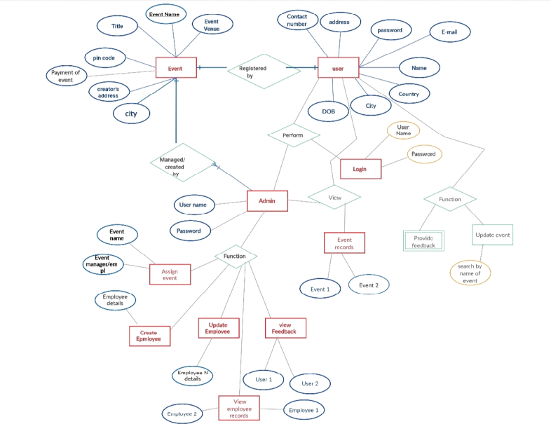

**E-R DIAGRAM FOR EVENT MANAGEMENT SYSTEM**

Entity-Relationship Diagram of Event Management System gives a conceptual model of our database, to help understand and communicate the semantics between the entities, a relationship is also labeled, this labeling is done correctly, the relationship can be read as a sentence.

**SCHEMA**

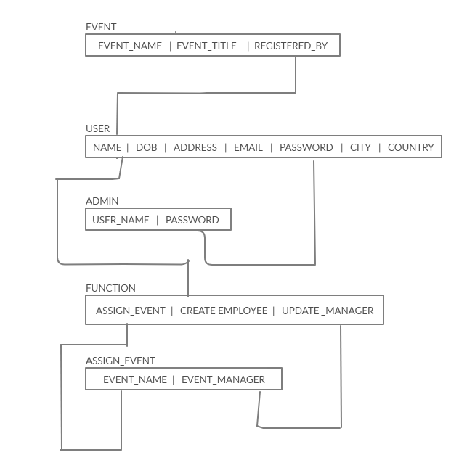

**SCHEMA DIAGRAM FOR EVENT MANAGEMENT SYSTEM**

The diagrammatic simplicity and communication clarity of the symbolic conventions in schema should not be underrated .There is a rich amount of semantics captured even in this simple example, single sales order may result in one or more service requirements.

**CHAPTER 3**

**SOFTWARE REQUIREMENT**

**3.1 FRONTEND TECHNOLOGY**

**List of technologies for frontend**

**1. Hyper Text Markup Language (HTML)**

Hypertext Markup Language is the standard markup language for creating web pages and web applications.

**2. Cascading Style Sheets (CSS)**

Cascading Style Sheets is a style sheet language used for describing the presentation of a document written in a markup language like HTML

**3. JavaScript**

JavaScript, often abbreviated as JS, is a high-level, interpreted programming language. It is a language which is also characterized as dynamic, weakly typed, prototype-based and multi-paradigm.

**3.2 BACKEND TECHNOLOGY**

**List of technologies for Backend**

**1.PHP**

Hypertext Preprocessor is a server-side scripting language designed for Web development, and also used as a general-purpose programming language. It was originally created by Rasmus Lerdorf in 1994, the PHP reference implementation is now produced by The PHP Group.

**Database:**

**MYSQL:**

MySQL is an open-source relational database management system. Its name is a combination of "My", the name of co-founder Michael Widenius's daughter, and "SQL", the abbreviation for Structured Query Language.

**CHAPTER 4**

**IMPLEMENTATION**

**ADMIN:**

* Admin first has to login with the username and password. After login, he gets the dashboard.
* Admin can view all the events that are registered by different users.
* Admin has to assign his employees to the events hence after viewing the events admin redirects to the assign event page in which the assigns the employees to different position like event manager, catering head etc and assigns the estimated cost which the user has to pay for the event.
* Admin also has the access to fill the details of his employee using the create employee page and also view the details of employee.
* Admin can edit, delete the employee or event details anytime he wants.
* Admin can also view the feedback given by different users.

**USER:**

* Users first go to the website and check out the services offered.
* If the user already has an account then he directly logins using the username and password and registers for his desired event.
* If the user doesn’t have any account then he registers himself and creates an account. There is a register form and user has to fill his details and create an account with an username which can be used anytime to register for n number of events.
* User registers for the event with the event registration form after he the login which redirects him to the dashboard.
* Registration of event is done by filling in the details of the form for the preferred choices of user.
* Users can give their valuable feedback about the service given to them

**Chapter 5**

**SCREENSHOTS**

**Home Page:**

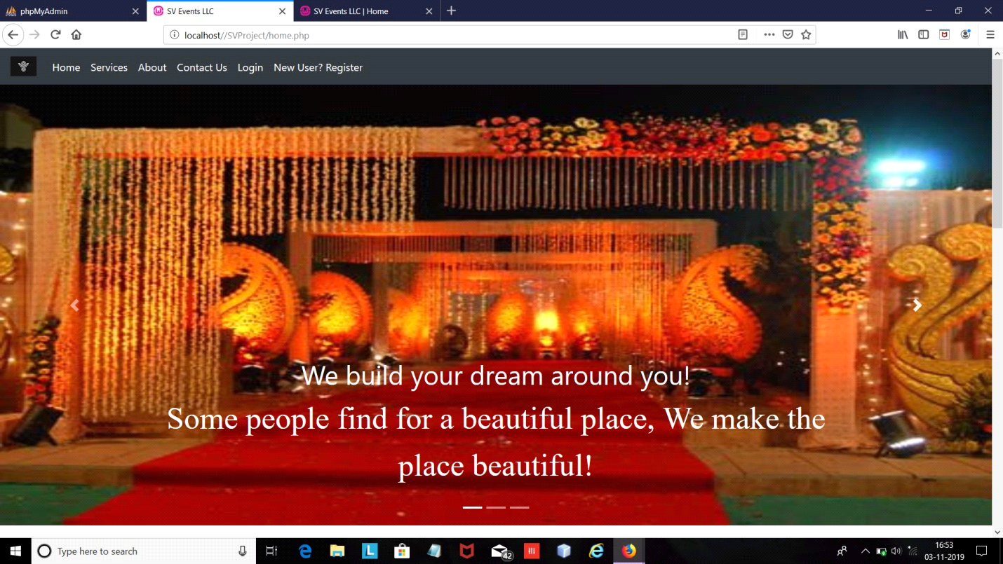

This is the front page of our website. This come as a slideshow of pictures events offered by us along with a short description or a relevant quote.

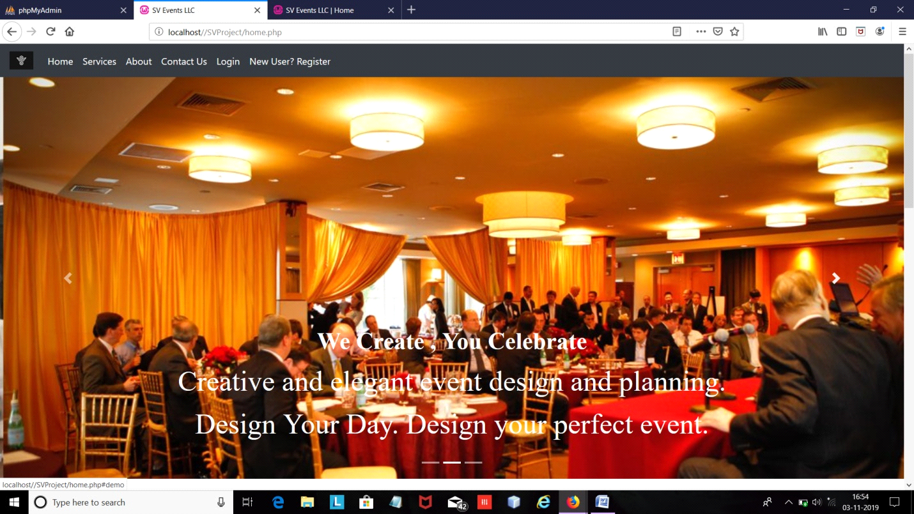

Here, we can see there is a Navigation bar at the upper border of the web page. It consists button read as HOME, SERVICES, ABOUT, CONTACT US, LOGIN and REGISTER.

**About:**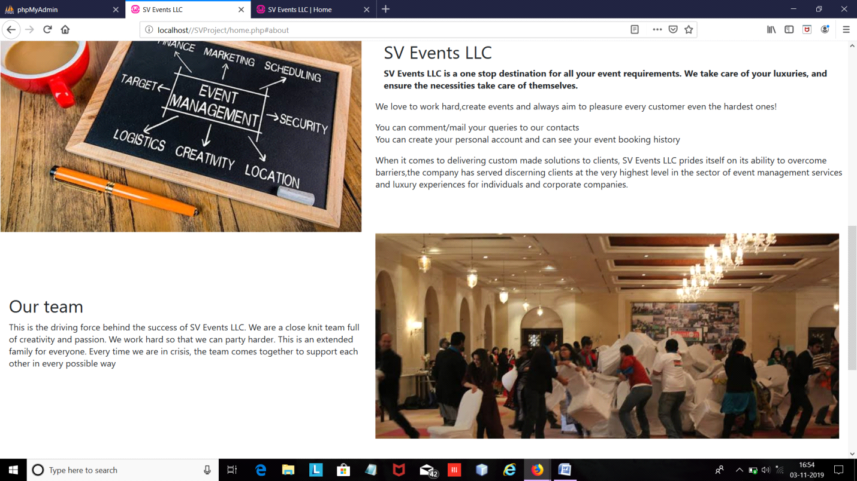

This is a page describing about who we are and how we have become what we are today. Along with current standing, it does have a short description about our journey and intro for our team members.

**Contact Us:**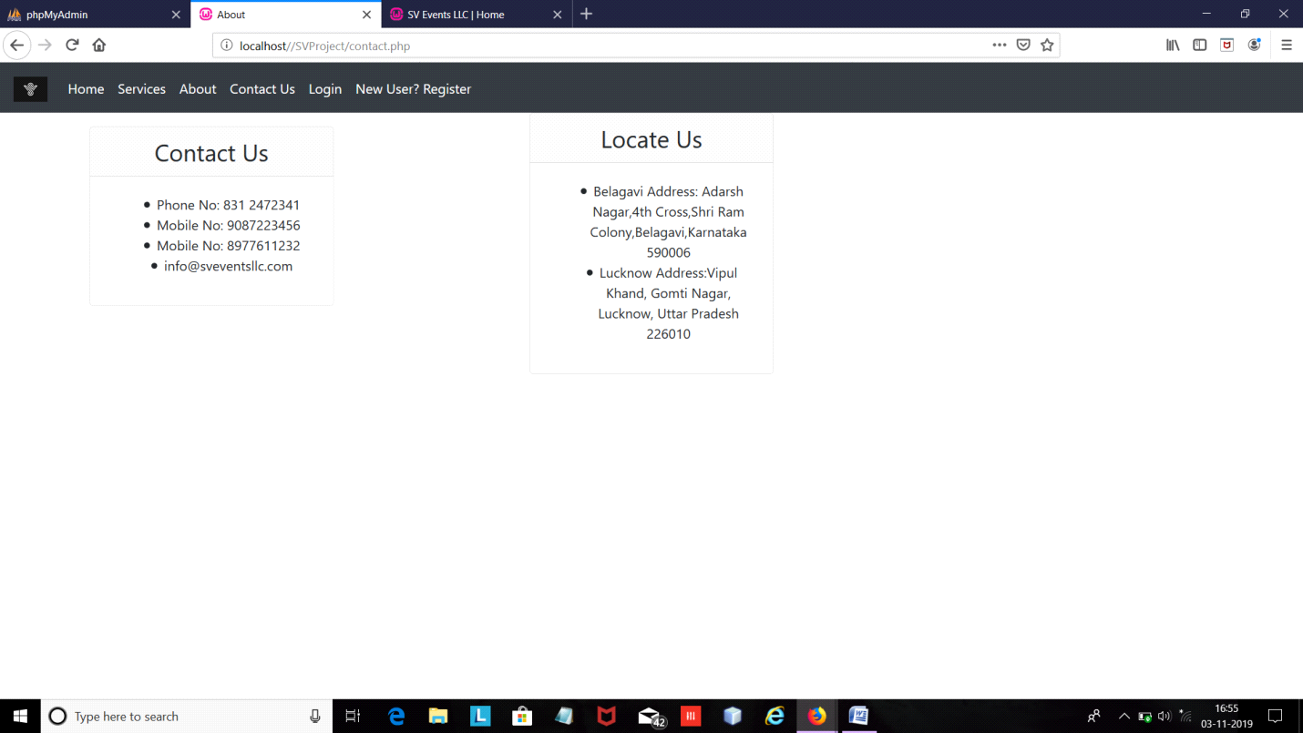

This page is self descriptive in nature. Here we give our clients and employees a platform and facility to establish contact, directly to the founders. They can write as well to us, and even can visit us.

**User Login:**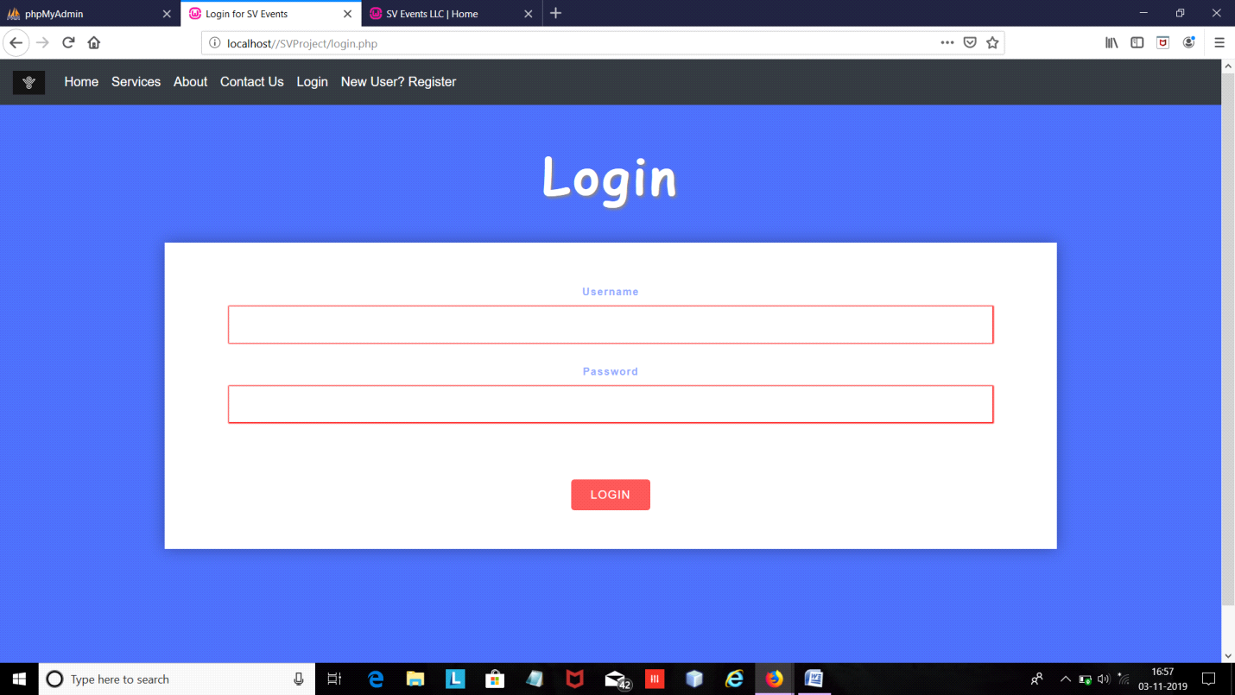

This is the login page for the user.Users can login here if they have created an account already.

**Event Registration Form:**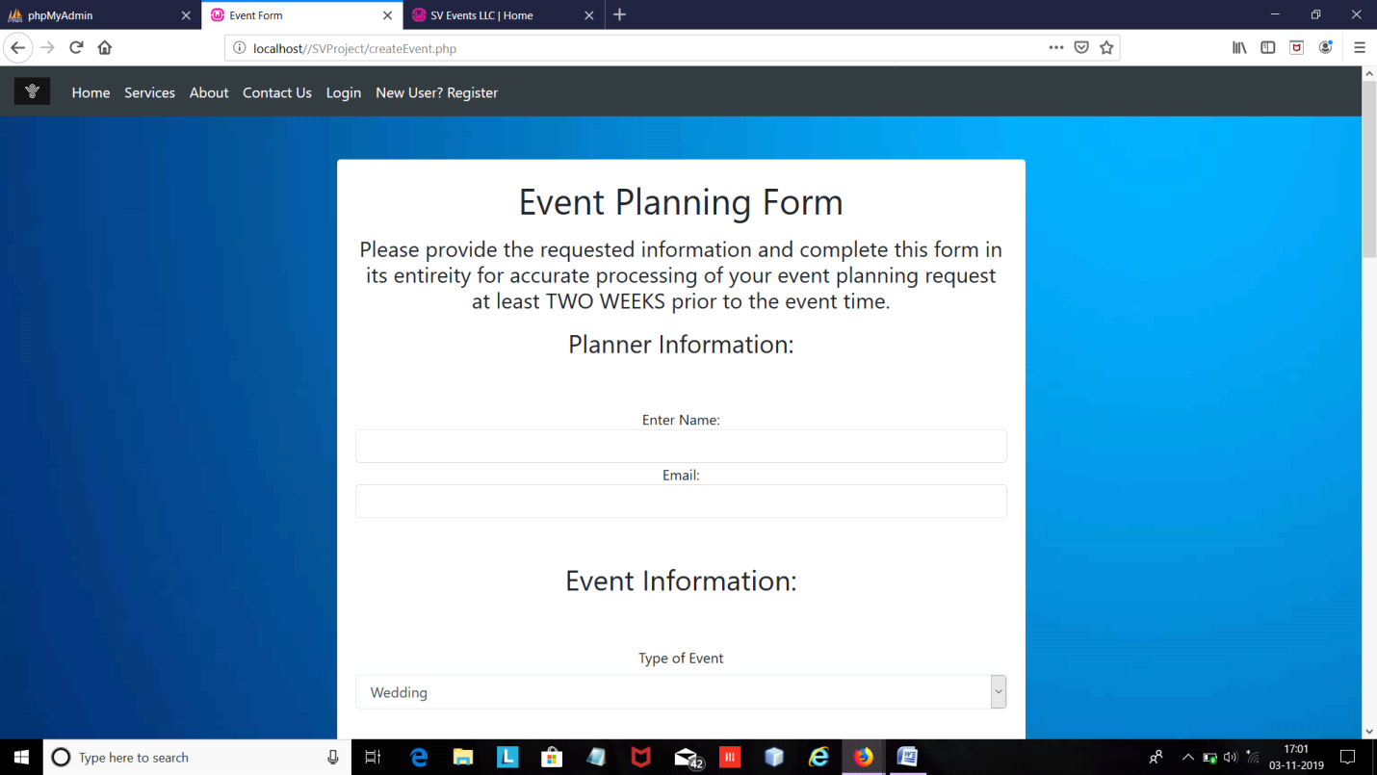

Users can register for events here. Screenshots are self-descriptory in nature.

Users fill in the details for their desired events.

**Event Registration Form:**

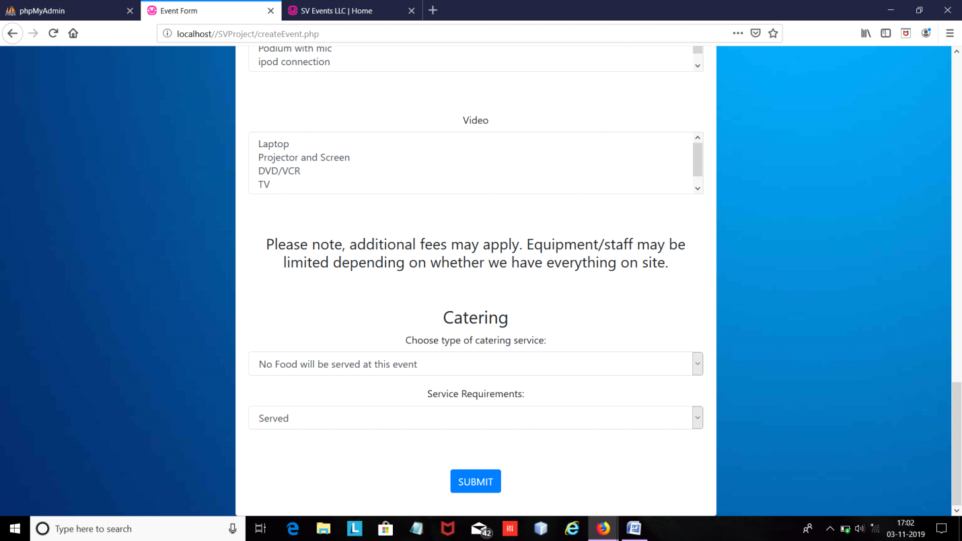

We have provided a drop down menu for the services/options offered. The <option> elements defines an option that can be selected and by default the first item is selected.

**After Successful Registration of Event:**

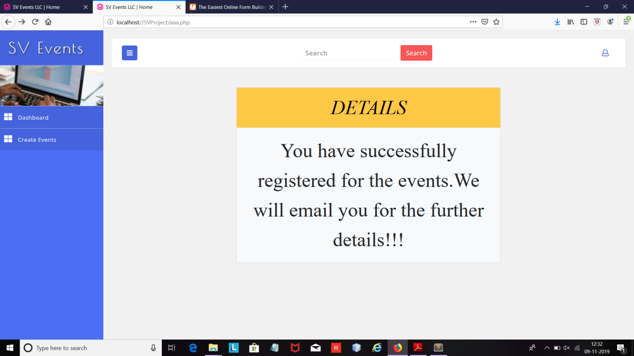

After the user registers, this page is displayed for the confirmation to the user that there was no problem in the registration of his desired event.

Feedback Form:

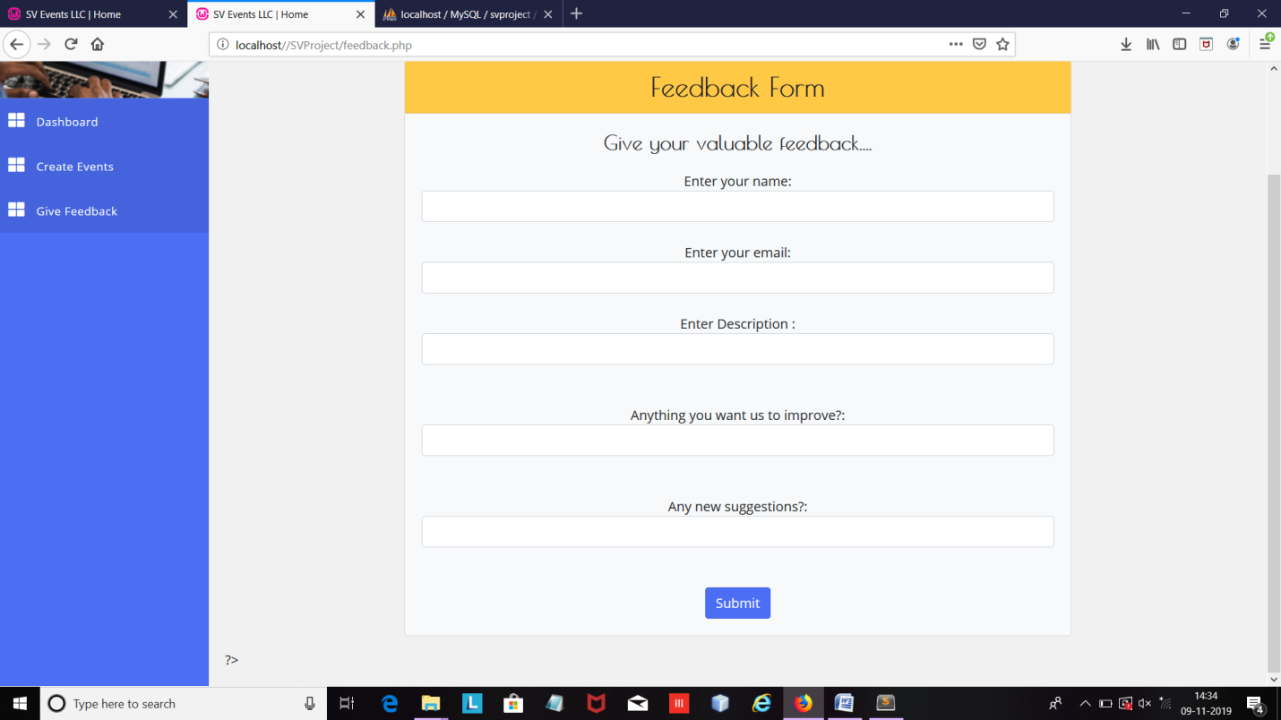

Users can give their valuable feedback after the success of the event. They can provide description of the event, suggest new ideas and tell us about any improvement is needed or not.

**Services:**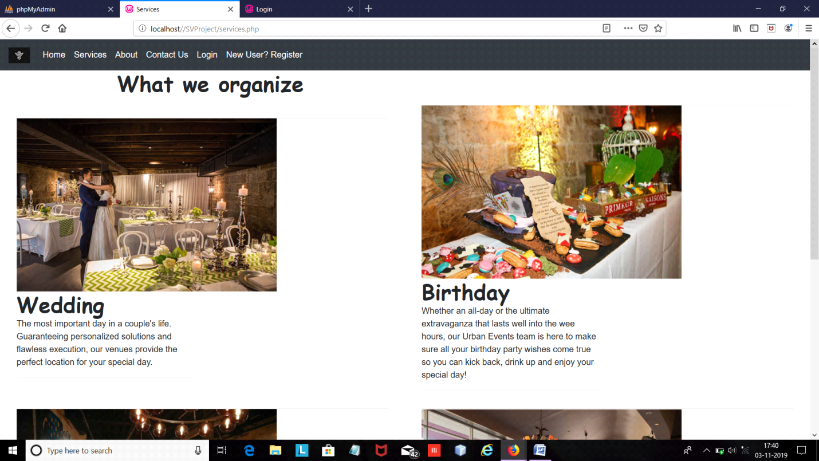

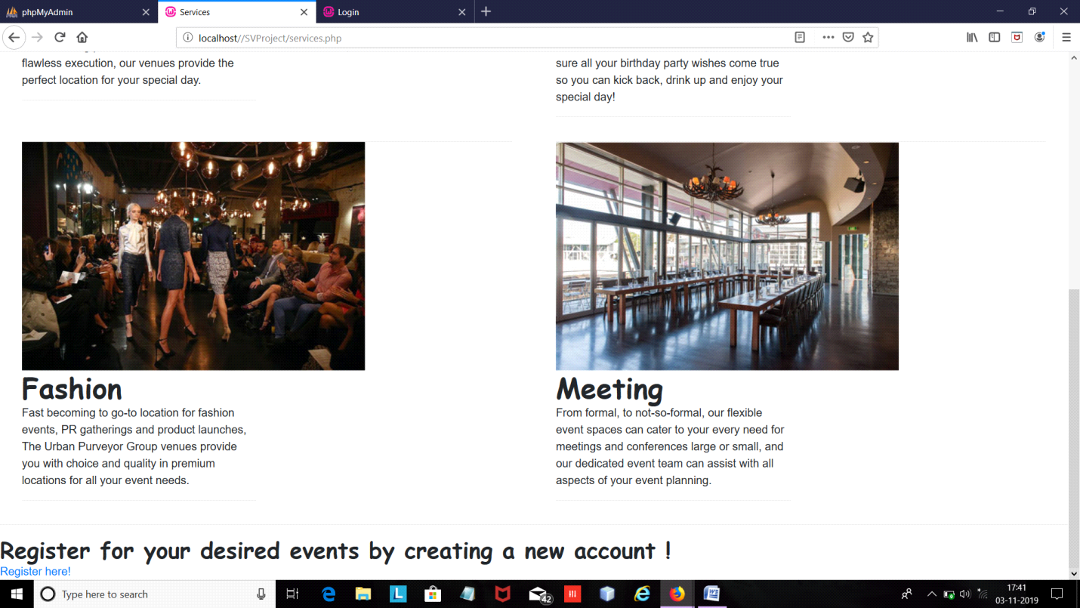Services being offered by us. It acts as catalog for users. They can see and if they're interested, they can just directly register for events, using the provided link at the bottom of the page

**User Registration Page:**

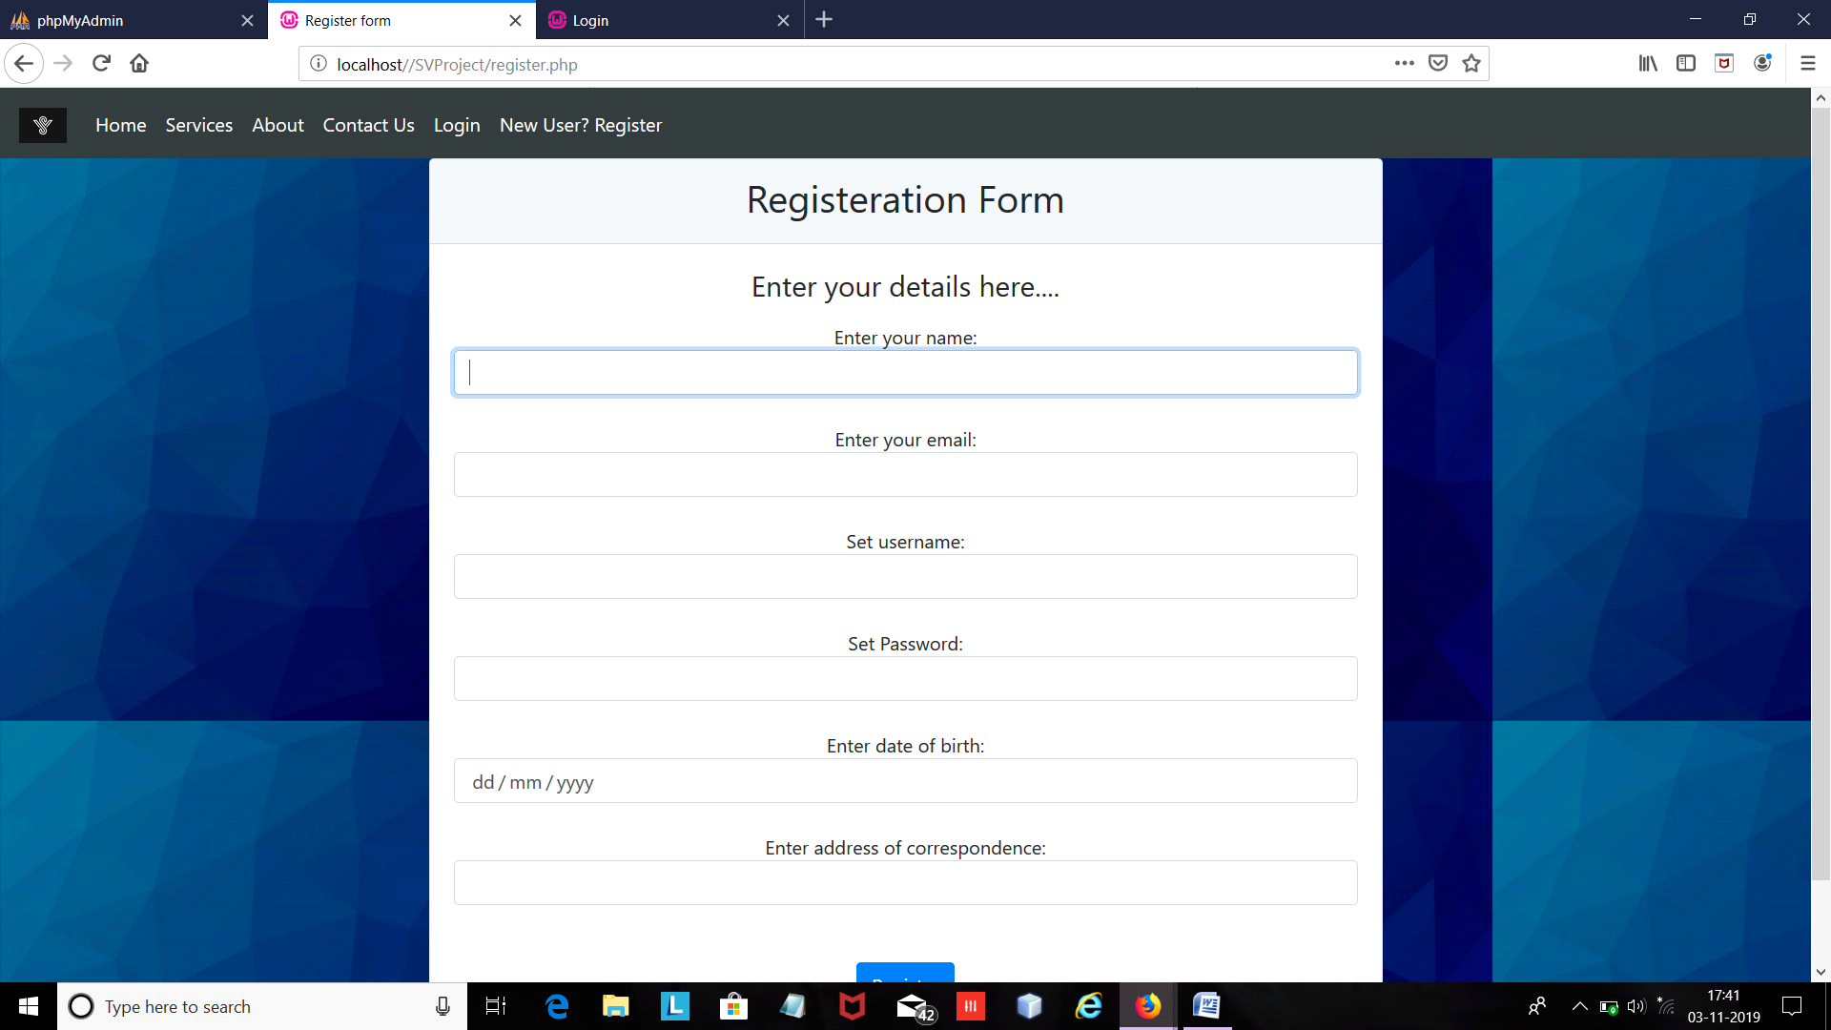

If in a case user is not registered, he can't directly login. For that a user is provided a facility to register him/her.

**Admin Login**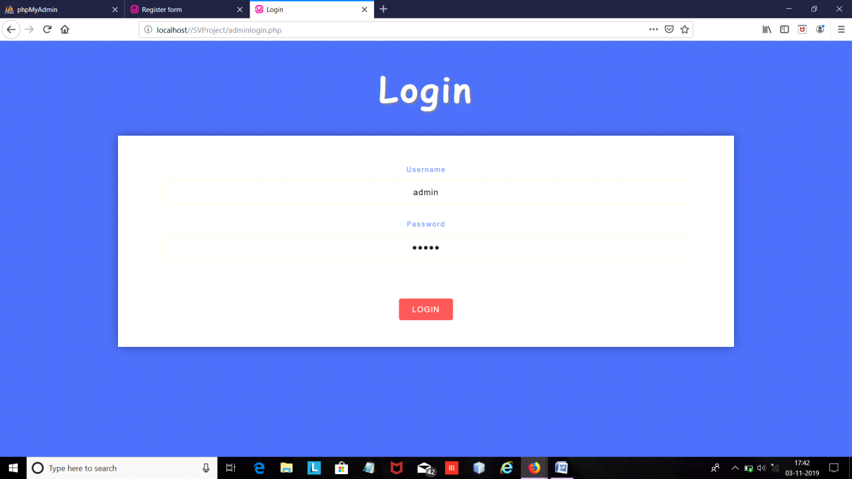

This page comes with some exclusive access rights. Here, only the website admin can login.

**Dashboard:**

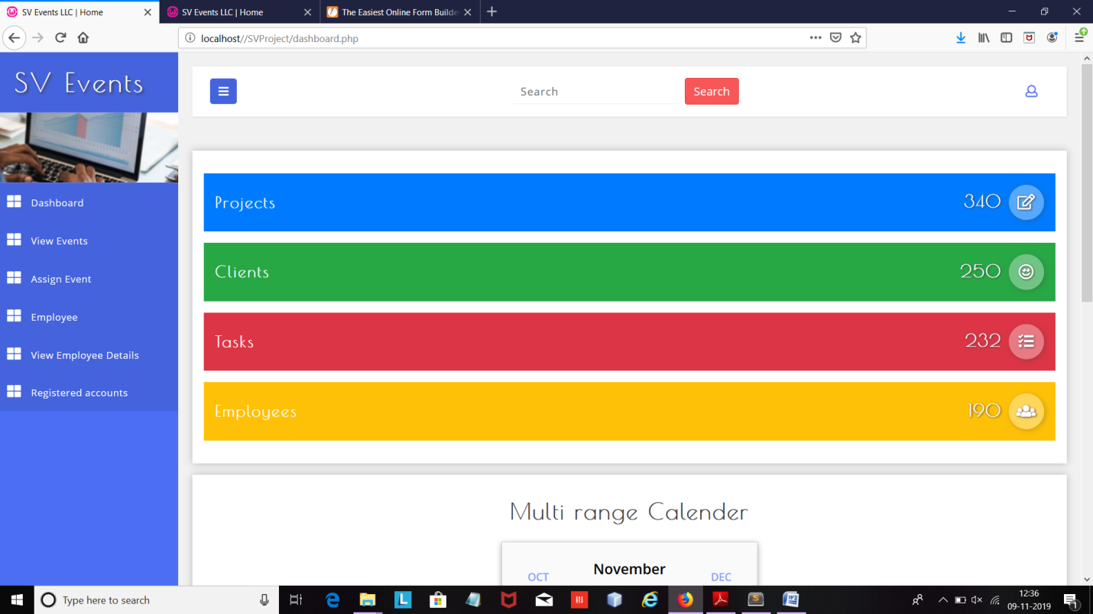

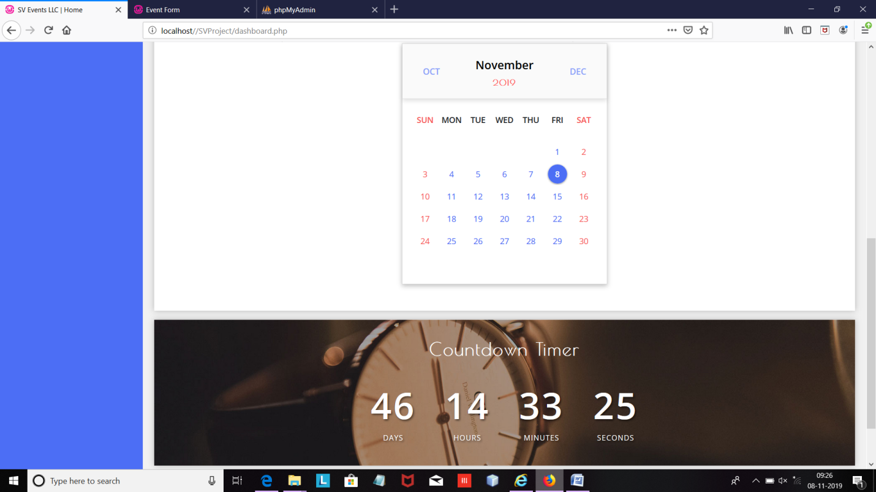Dashboard contains different options considerin who's logging in. User dashboard has facility of registering event and viewing the registered events while admin dashboard has a facility of assigning events, looking at all the events, adding both employees and events.

**View Events Page:**

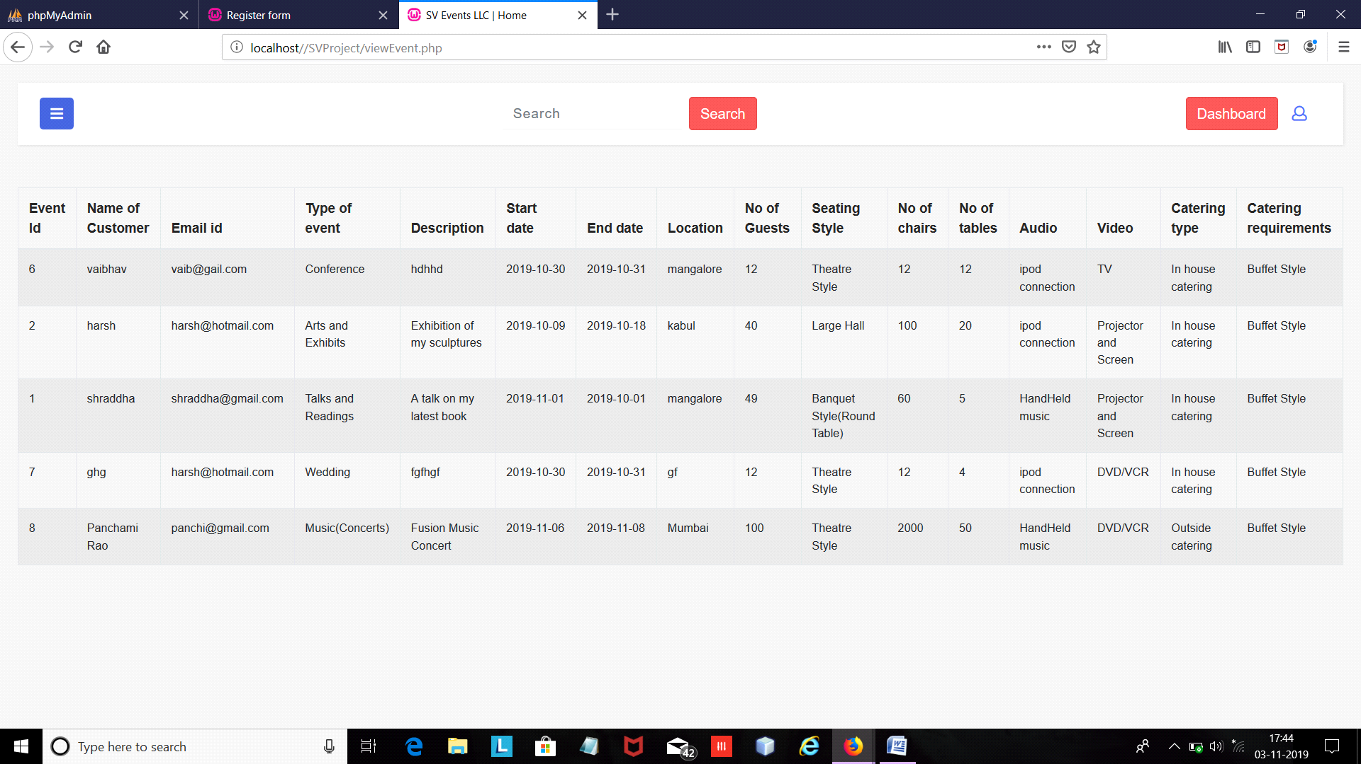

Here the admin views all the events that different users have registered for.

Here we have used a table to display the details of the events that the user has registered.

**Assign Event Page:**

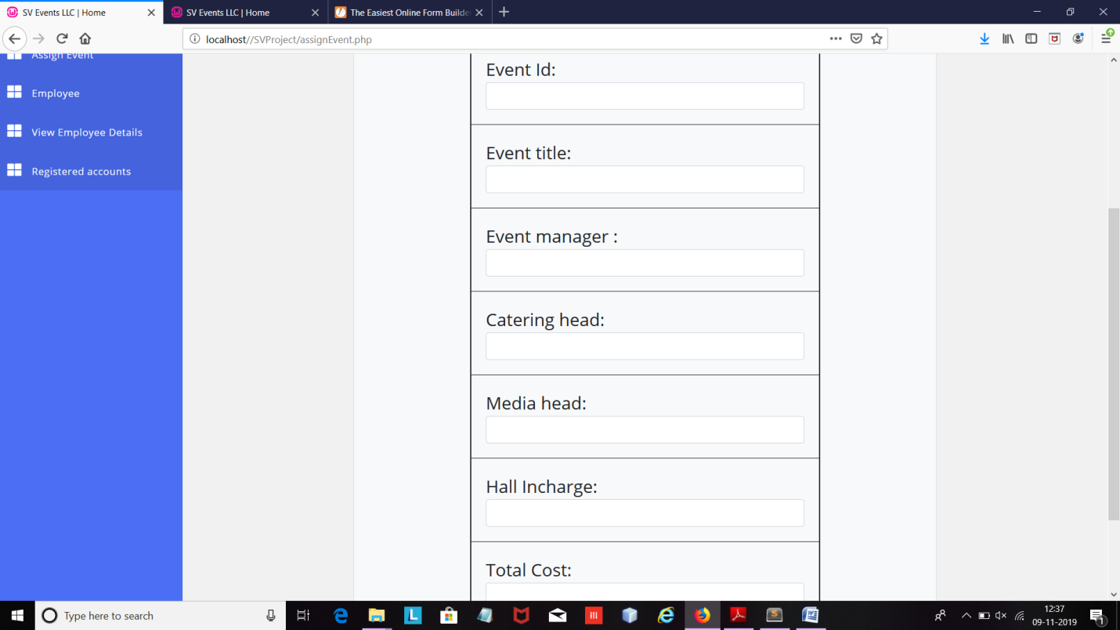

Admin assigns the event manager, catering incharge, hall in charge and media in charge for the events registered by the users.

Admin also assigns the cost that the user has to pay for the event he has registered.

**Create Employee Page:**

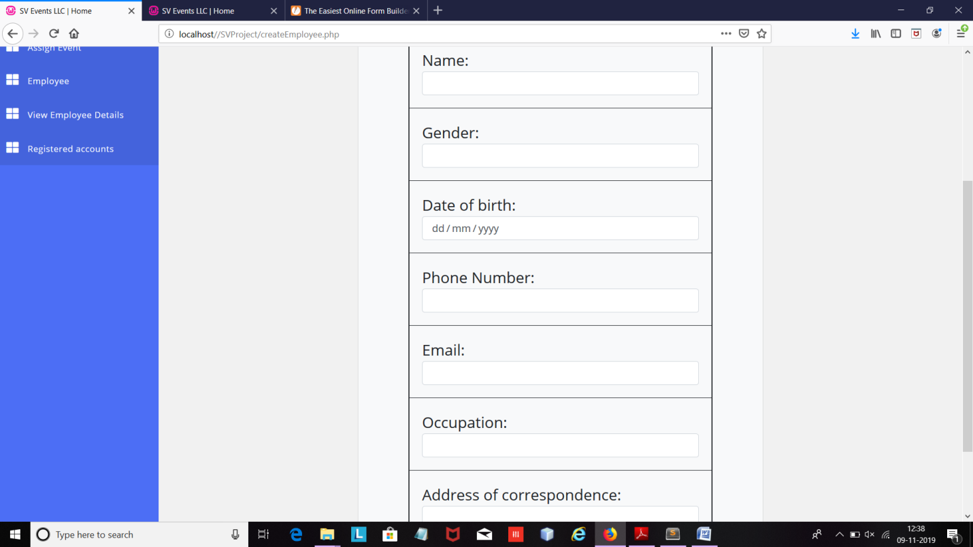

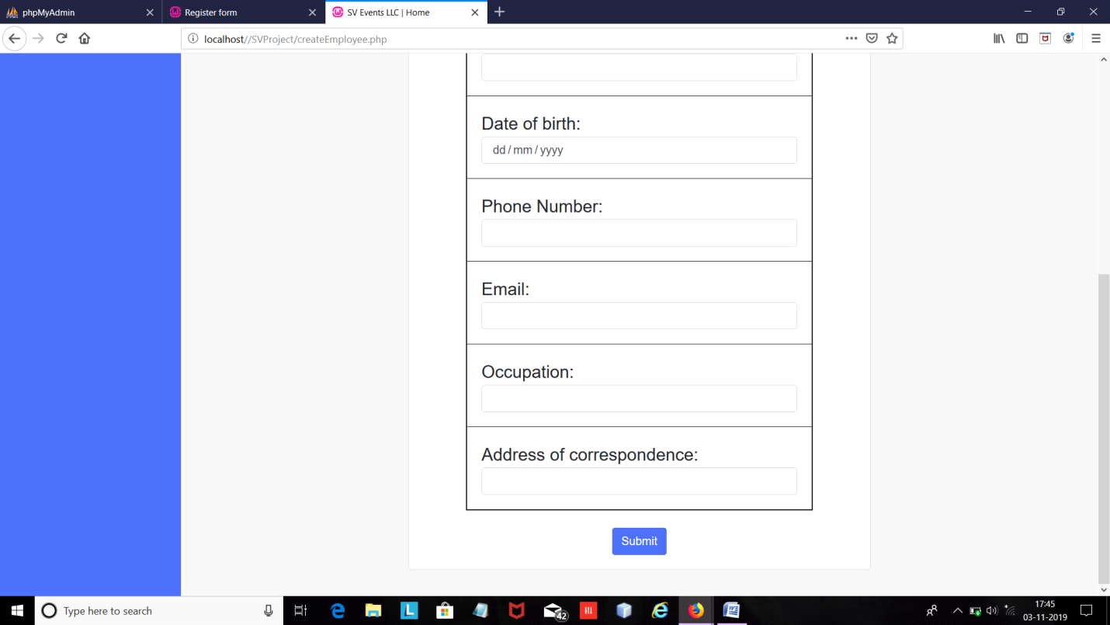These are the facilities inside the dashboard. This mainly includes forms for registration and assignment of events and registration of employees.

**View Employee:**

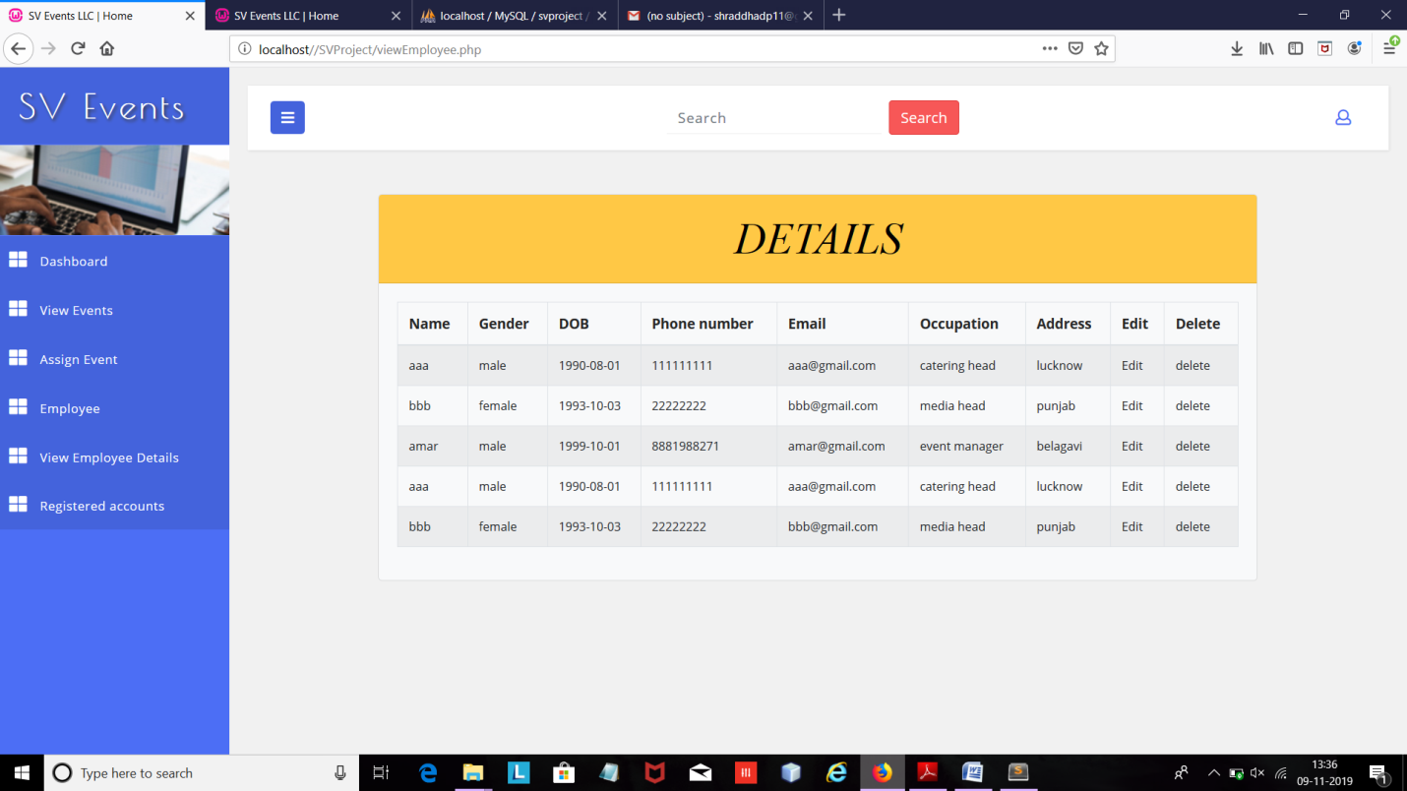

Here the admin views the employee details who are working in the company so as to assign them for events.

Admin can also edit the details of employee and even delete the details.

**Edit Employee Details:**

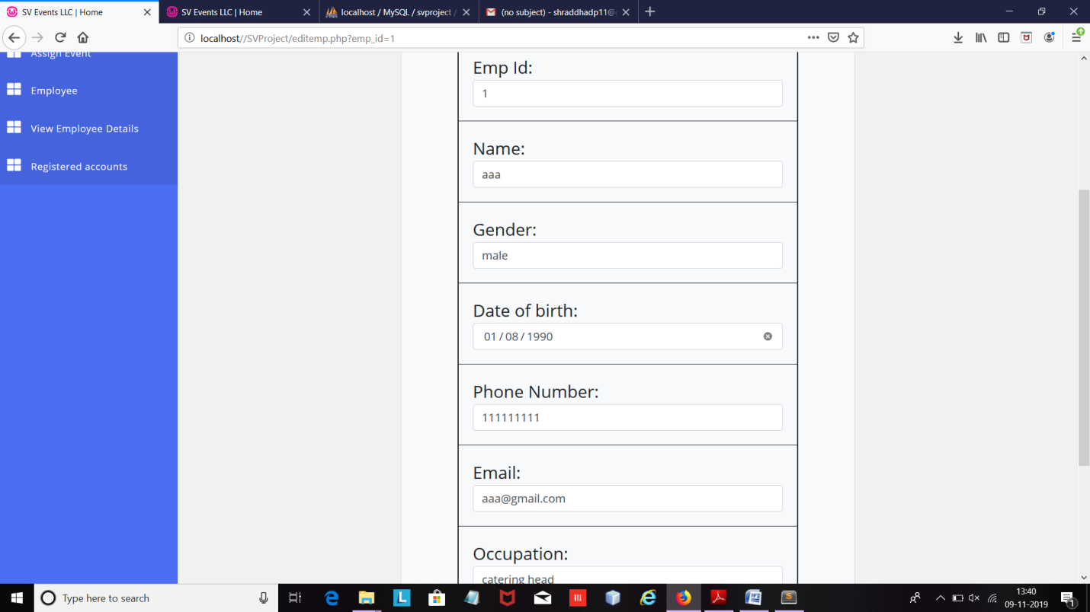

As we can see here the details are already generated, the admin can now enter the new details of employee and click on submit. After this the details of employee are updated.

**Registered Accounts:**

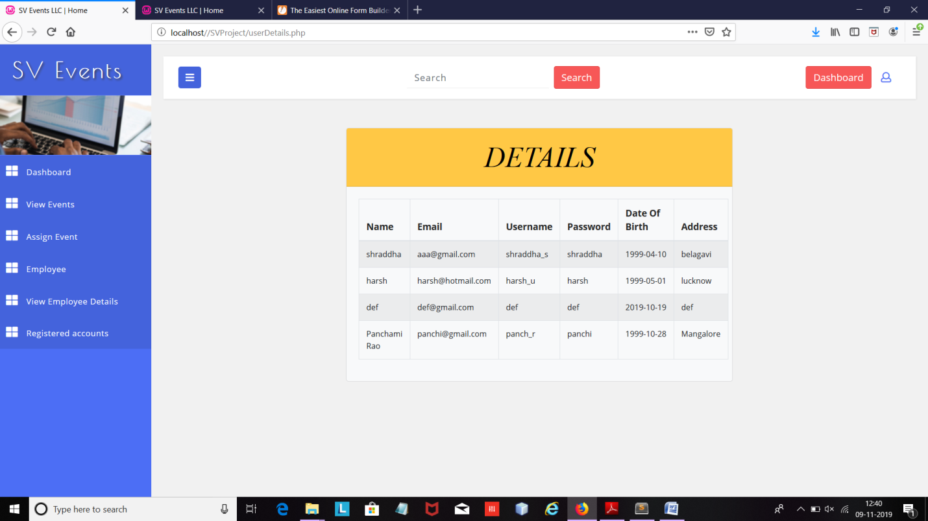

Here admin can view all the registered accounts on the website.

**CONCLUSION**

Our project is only a humble venture to satisfy the needs to manage their project work. Several user friendly coding have also adopted. This package shall prove to be a powerful package in satisfy all requirements of the user. The objective of software planning is to provide a frame work that enable the manager to make reasonable estimate made within a limited time frame at the beginning of the software project and should be update regularly as the project regularly.

At the end it is concluded that we have made effort on following points…

• A description of background and context of the project and its relation to work already done in the area.

• Made statement of the aims and objectives of the project. • The description of the purpose, scope and applicability.

• We define the project on which we are working in project.

• We describe the requirement specifications of the system and actions that can be done on these things.

• We designed user interface and security issues related to system.

• Finally the system is implemented and tested according to the test cases.

**REFERENCES**

**1.** [**www.stackoverflow.com**](http://www.stackoverflow.com/)

**2.** [**www.youtube.com**](http://www.youtube.com/)

**3.** [**www.w3schools.com**](http://www.w3schools.com/)

**4.** [**www.w3layouts.com**](http://www.w3layouts.com/)

**5.** [**www.jotform.com**](http://www.jotform.com/)

**6.** [**www.getbootstrap.com**](http://www.getbootstrap.com/)

7. Textbook: Elmasri and Navathe,”Fundamentals of Database Systems”, Fourth Edition, Pearson Education